Website Style Guide – Example Project

# Friends OF North Creek Forest Description

**Goal:** To inspire people to become involved with North Creek Forest. To promote the community to utilize the educational programs and to volunteer to Maintain, Improve and Conserve the 64 acre forest. To secure donations to assist in support of educational programs and of bringing forest awareness.

**Target Audience:** The site is intended to reach people who are interested in conservation and sustainability. People who enjoy hiking, family outings in nature and those who enjoy seeing wildlife in their natural setting.

**Personality:** Warm and earthy with a clean, natural community feel.

The site will help people feel more connected with protecting and preserving nature.

# Color Palette

The following is the list of colors that may be used. Tints or changes in opacity may also be used as long as they compliment each other. These are Web safe Colors.

|  |  |  |  |  |
| --- | --- | --- | --- | --- |
| #FDFEF7  (253,254,247) | #27343A  (39,52,58) | #44634F  (68,99,79) | #96C179  (150,193,121) | #C26E37  (194,110,55) |
| Background | Lettering | Site | Accent | Highlight |
|  |  |  |  |  |

* A very light cream was chosen to create a soft warm tone, as well as to keep edges sharp and clean, as per the strategic brief.
* The lettering color is pulled directly from the logo which will tie in nicely. Background color will be used as a contrast lettering color when necessary.
* The greens are descriptive of the evergreen and moss-like colors around the Northwest and within the forest itself and will be the primary colors found on the website.
* The pumpkin/orange color is indicative of fall leaves and adds quite a bit of warmth to the site.

Every color listed is subject to tweaking and small changes due to the evolving site design.

# Image Licensing

## Humpback Whale

[Humpback whale jumping](https://commons.wikimedia.org/wiki/File:Humpback_whale_jumping.jpg#/media/File:Humpback_whale_jumping.jpg) ‎(750 × 500 pixels, file size: 150 KB, MIME type: image/jpeg)

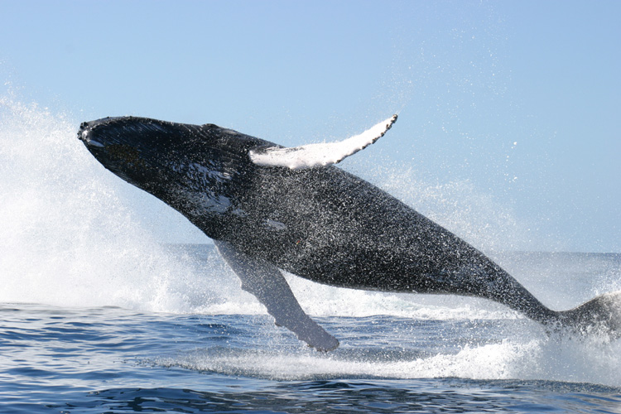

*This image is in the* [***public domain***](https://en.wikipedia.org/wiki/public_domain) *because it contains materials that originally came from the U.S.* [*National Oceanic and Atmospheric Administration*](https://en.wikipedia.org/wiki/National_Oceanic_and_Atmospheric_Administration)*, taken or made as part of an employee's official duties.*

## Whale Play Icon

### A cute little whale icon

URL: <https://openclipart.org/detail/222094/whale-animation>

License Info: Unlimited Commercial Use

We try to make it clear that you may use all clipart from Open-Clipart even for [unlimited commercial use](https://openclipart.org/unlimited-commercial-use-clipart).

# Font Families

**General Text** - Questa Sans, Arial, Helvetica, sans-serif

Fontspring Desktop License v1.60

*This license can be found at this permalink:*[*https://www.fontsquirrel.com/license/questa-sans*](https://www.fontsquirrel.com/license/questa-sans)

**Headings and Navigation** – Oswald, Garamond, Times, serif

FONT: **Oswald**

[**Vernon Adams**](https://plus.google.com/107807505287232434305/about)

[SIL Open Font License, 1.1](http://scripts.sil.org/OFL)

# Site Styling

## Overall Page Styling

The overall page colors are dark green text on a cream background using a 12-point, 1.1 line-height.

The entire page is a fixed width (1280px), centered design using the Laser Light image at 10% opacity to provide texture to the background.

Default colors for links are Dark Green for normal links, fall orange for visited links , and light green when you hover over links.

All definition lists (dl) have terms (dt) that are 1.1em in size, bold, peach with a 5-point margin around all sides. All definition list data (dd) has a 50-pixel right margin and 25 pixels of padding at the bottom.

## Header

The identity section uses 250 pixels of padding-left and the background-image whale positioned to the top left with no-repeat.

Use the heading font-family in this section. The h1 headers are 2em in size and bold while h2 headers are 1.6em in size, italic, and text-aligned: center.

## Navigation

Site navigation uses with a font-size of 1.2em and 10 pixels of padding top and bottom, but 20 pixels of padding left and right.

The navigation list of links is displayed inline, rather than as a block. Each list item uses .2em of padding, top and bottom, 1em of padding left and right. Each list item has a solid, thin, deep blue right border, except the last item.

## Content Section

The webpage content section uses a 20 pixels of padding all-around.

All headings in the content section are sized at 1.5em (h1), 1.3em (h2), and 1.1em (h3).

Unordered list items in the content section are 1.1em bigger than normal, and have an extra 0.5em padding top and bottom.

Ordered list items in the content section use upper-roman numbering for the main list and lower-alpha numbering for a sub-list. Ordered lists have 0.8em padding at the bottom.

## Footer

Includes a faded (20%) pink-blast background color with 15 pixels of padding around all edges.

Paragraph text is reduced in size to 0.8em, bold, and aligned center with a 1.1em line-height, but without any margin or padding.